AUTHORIZATION AGREEMENT FOR PREAUTHORIZED PAYMENTS (ACH)

I hereby jointly and severally authorize Tammy L. Terry, Chapter 13 Trustee, (the “Trustee”) to initiate credit and/or debit entries to My account indicated (the “Bank Account”) at the depository named below (the “Bank”). If necessary, credit entries may be made to initiate an adjustment entry for any entry made in error. By My signature below, I state that I have read and agree to be bound by the Rules of Participation of the Automatic Bank Draft Program and agree to obtain the permission of the United States Bankruptcy Court for the Eastern District of Michigan prior to asserting any challenge I may have to a credit or debit entry made by the Trustee pursuant to this Agreement.

This authorization will remain in effect until Trustee receives written notification from Me of its termination in such time and in such a manner as to afford Trustee and Bank a reasonable opportunity to act on it; or until the dismissal, discharge, or conversion of My proceeding under Chapter 13 of the United States Bankruptcy Code.

I, jointly and severally, agree to indemnify, protect and hold harmless the Trustee, his supervisors, agents, servants, employees, and all persons acting on behalf of the Trustee from any claim, liability or damages whatsoever, including, but not limited to, bank fees, court costs, attorneys' fees and interest, however caused, arising directly or indirectly out of the implementation, operation, interpretation or termination of this Agreement or any failure of or delay in any of the foregoing.

Name: | Case #:
Address: | City:
State: | Zip Code:
Phone # (Home): | Phone # (Work):
Attorney Name: | Attorney E-mail:
Bank Name: | Address:
City: | State:
Zip Code: | Phone #:
Transit/ABA #: | Account #:
Type of Account: Checking Savings | Draft Date: 5th of month 17th of month
Amount Per Month: Trustee is authorized to change this amount (increase or decrease) pursuant to applicable law or Order of Court without prior notice
Signature: Date: / /20
Signature: Date: / /20
All parties to the Account designated above (the “Account Holders”) must sign this Agreement, whether such party is a Debtor in Bankruptcy. By signing this Agreement, each Account Holder agrees to be individually bound by this Agreement.

IF THE DESIGNATED ACCOUNT IS A CHECKING ACCOUNT, PLEASE INCLUDE AN IMAGE OF A VOIDED CHECK HERE

if a savings account is being designated, please contact your savings institution and obtain and attach written verification of the proper TRANSIT/ABA # and the proper ACCOUNT #.

Upload the completed ACH form and supporting documents (as a single document) in the following naming convention (XX-XXXXX_3716_ACH_Termination.pdf where XX-XXXXX is the Chapter 13 case number) to our office using https://www.bkdocs.us .

PARTICIPATION RULES OF THE AUTOMATIC BANK DRAFT PROGRAM

- This program is limited to those cases in which the Court has entered an Electronic Transfer of Funds Payment Order (the “ACH Order”). The ACH Order must be entered before submitting the Authorization Agreement for Preauthorized Payments (ACH) (the “Agreement”) to the Trustee.

- This program is intended only for debtors with income as to which a Third-Party Payment Order cannot be effectuated such as social security and disability; or as to whom the Court has excused the requirement for a Third-Party Payment Order. See E.D. Mich. LBR. 1007-1(C).

- Bank Account Holder(s) must request to participate by completing the “Agreement” and returning the signed Agreement to the Trustee. The Agreement is also available on the Trustee’s Web Site at https://www.det13.net/debtors/ach_information/. Agreements that are incomplete or are not signed by all Account Holders cannot be implemented by the Trustee.

- There may be a delay in the implementation of this Agreement from the time of receipt of this Agreement by the Trustee. You understand and agree that You must make all Plan Payments that come due prior to the implementation of this Agreement, by check or money order mailed to the Trustee.

- You may choose either the 5th or the 17th day of the month for Your payment to be debited, regardless of Your actual payment due date. Should the 5th or the 17th of the month fall on a bank holiday or on a weekend, the Bank Account will be debited on the first business day thereafter.

- The Trustee reserves the right to deny this privilege to any person.

- The Trustee may terminate this Agreement without prior notice if the Bank Account contains insufficient funds to permit any withdrawal to occur.

- You authorize the Trustee to initiate credits to the Bank Account, to adjust any entry made in error to the Bank Account.

- You have the right to terminate this Agreement at any time upon written notice signed by all Account Holders. The Termination Form is available on the Trustee’s Web Site at https://www.det13.net/debtors/ach_information/

- If You terminate this Agreement, the Trustee shall have a reasonable time after receipt of notice within which to effectuate the termination. You agree to indemnify and hold Trustee, his supervisors, agents, servants, employees, and all persons acting on behalf of the Trustee from any claim, liability or damages whatsoever, including, but not limited to, bank fees, court costs, attorneys' fees and interest, resulting from or incurred at any time prior to the Trustee’s effectuation of Your request for termination of this Agreement.

- You will be notified in writing by the Trustee if this service is terminated. Upon receipt of the Notice of Termination, you must make all future Chapter 13 plan payments by check or money order mailed to the Trustee.

- The Trustee reserves the right to amend these rules at any time without prior notice.

FREQUENTLY ASKED ACH QUESTIONS

Q. HOW CAN I FIND THE TRANSIT/ABA NUMBER AND ACCOUNT NUMBER FOR MY CHECKING ACCOUNT?

A. For a checking account, the Transit Number (also called a “Routing Number” or “ABA number”) is located on the front of the check. It will be a 9-digit number appearing on the bottom left corner of the check.

Find the special characters . The Transit Number is between these characters.

The Account number will be the string of numbers appearing immediately to the right of the Transit Number. It may vary anywhere from 6 to 9 digits, depending on Your Financial Institution.

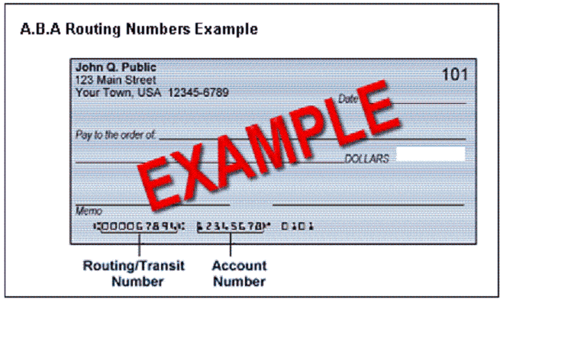
Q. HOW CAN I FIND THE TRANSIT/ABA NUMBER FOR MY SAVINGS ACCOUNT?

A. The Transit Number (also called a “Routing Number” or “ABA number”) does not appear on the face of a savings deposit or withdrawal ticket. You must contact Your financial institution to obtain the Transit Number.

Q. CAN I EMAIL THE ACH DOCUMENTS TO YOUR OFFICE?

A. No. The documents must be uploaded securely using the bkdocs.us web site.

